Process Document of Procurement Kit creation & its workflow execution
Submitted to:
Kirloskar Oil Engine Limited(KOEL)
Date: 24 October 2019

Revision 1.0

Submitted By:
Kloudq Technologies Limited
Plot No.1,Yena,Adwaitnagar,
Paud Phate,Erandawana,
Pune-411038,Maharashtra,INDIA

Document History:

Version | Author | Date | Comments
1.0 | Rohan Indalkar | 23/05/2019 | First Release
2.0 | Rohan Indalkar | 24/10/2019 | Second Release

Table of Contents
1. Procurement Kit Creation Steps: 4
2. New Part Development Process: 17
3. Additional Quantity Tracking Process: 19
4. Procurement Kit Closure: 20
5. Revision of Kit for Updating hold tag: 23
6. Procurement Kit Task Report: 25

Procurement Kit Creation Steps:
- Search the required App. code from Windchill from which the data is to be extracted
Click Structure Tab Reports Multilevel BOM

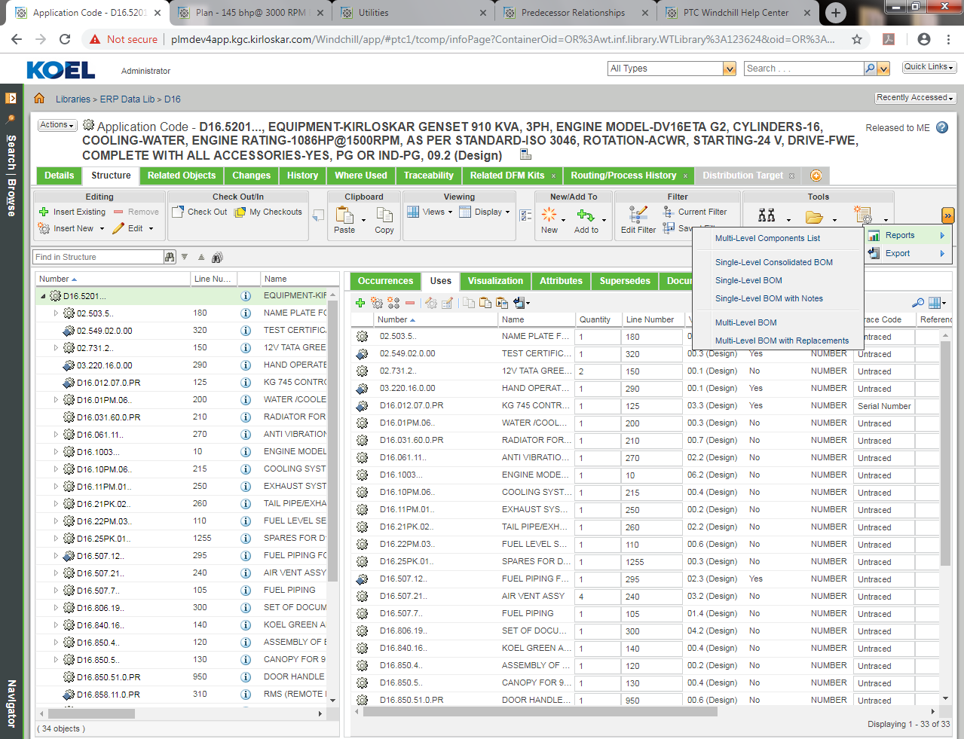

- Once Multilevel BOM option is selected. Click on drop down menu select Kit_View.
Actions Export List to File Export List to CSV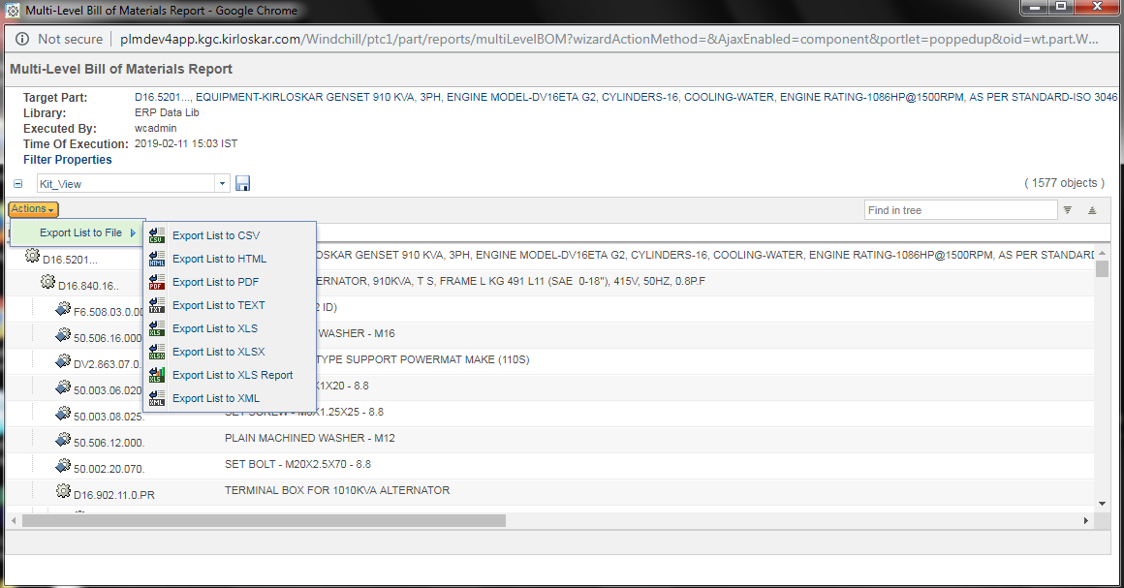

The data is extracted in below format. Apply filter and select the required objects.
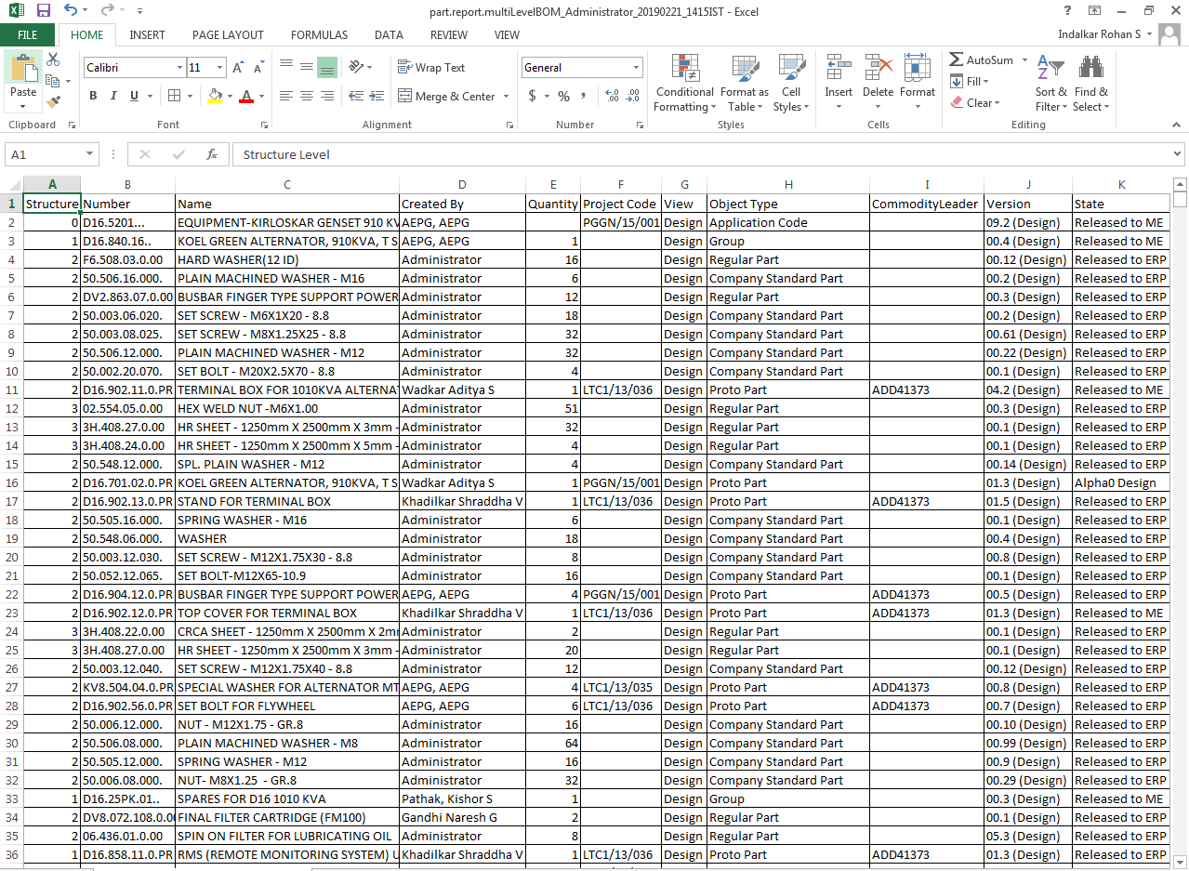
Apply filter according to Project code, Created by (Exclude Administrators), Version & State of the part (Released to ERP). Below is the filtered data.
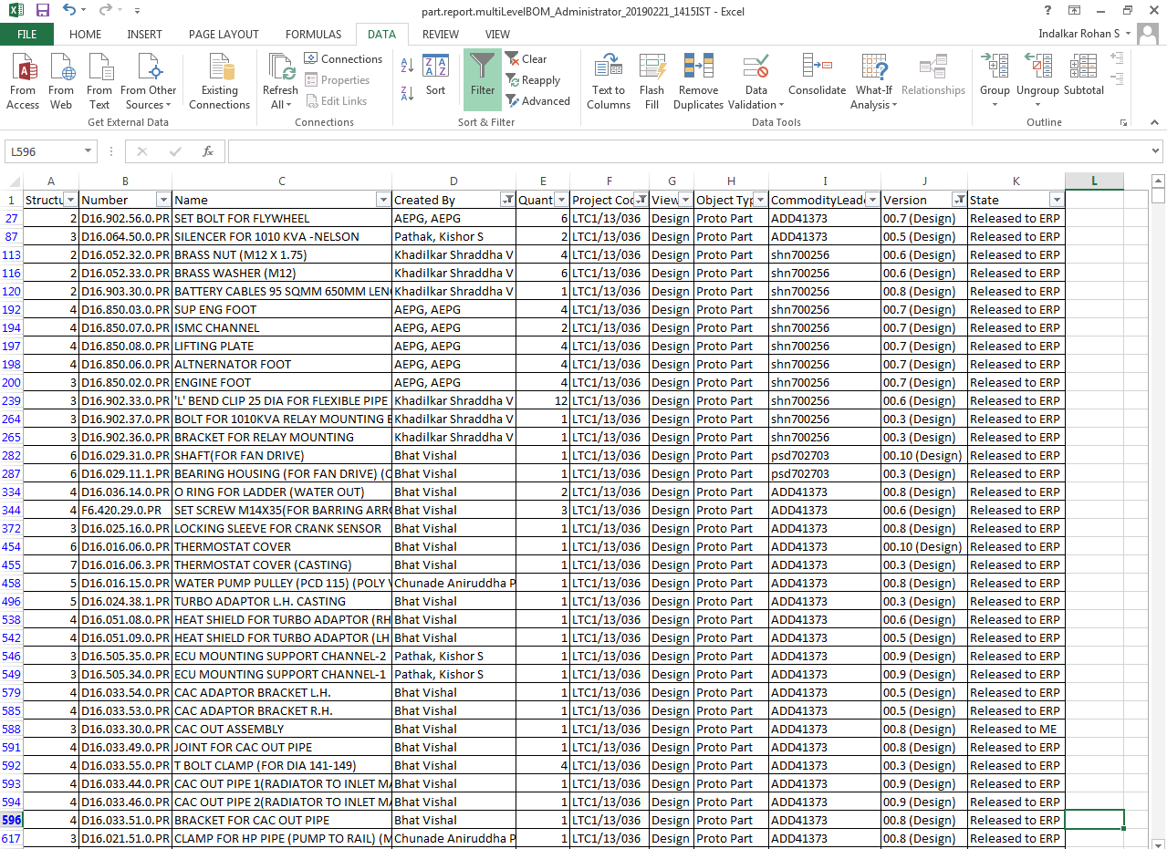
- Copy the data from the above extracted report and paste in the provided template as shown below.
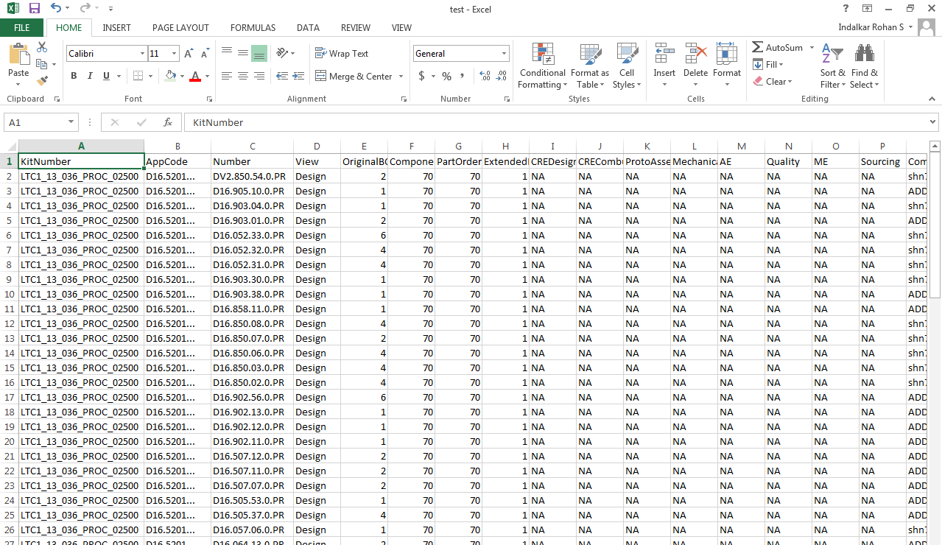
- Kit Creation Process:

Navigate Click on Browse ERP Data Lib Folders
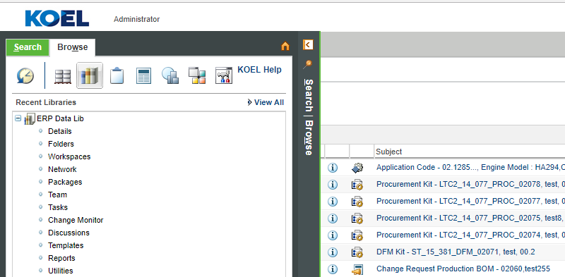
- Click on New Koel Part icon.
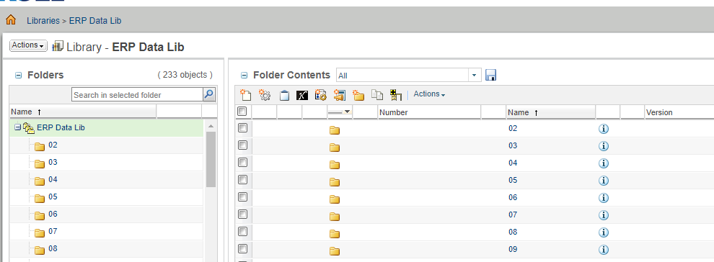
- Select type as KOEL Procurement Kit. Fill the required fields. Click on Finish.
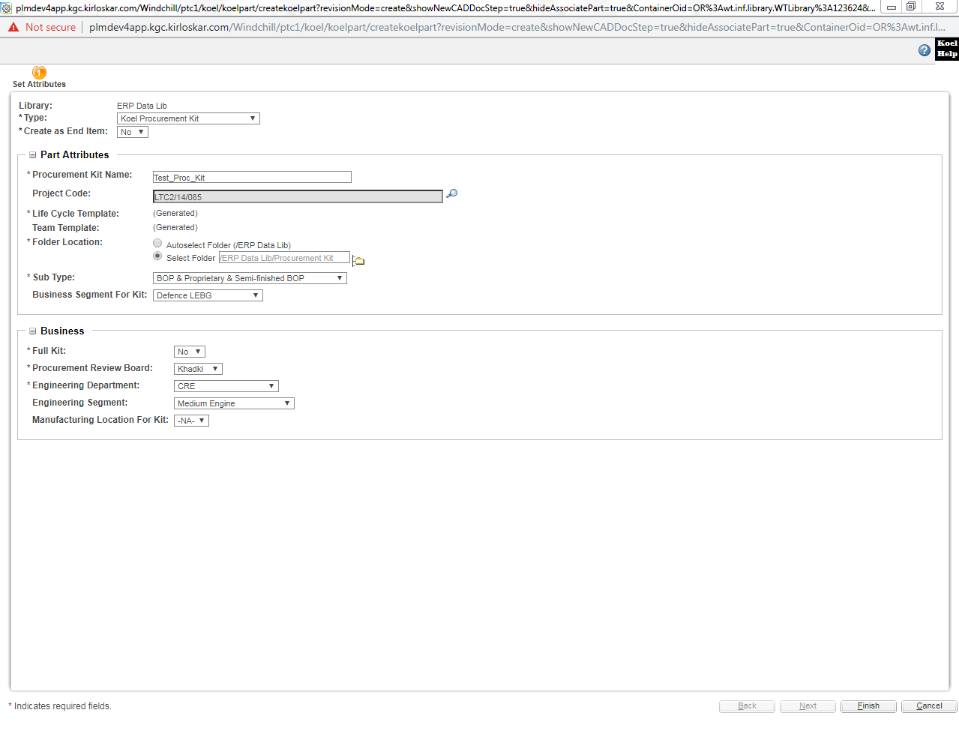
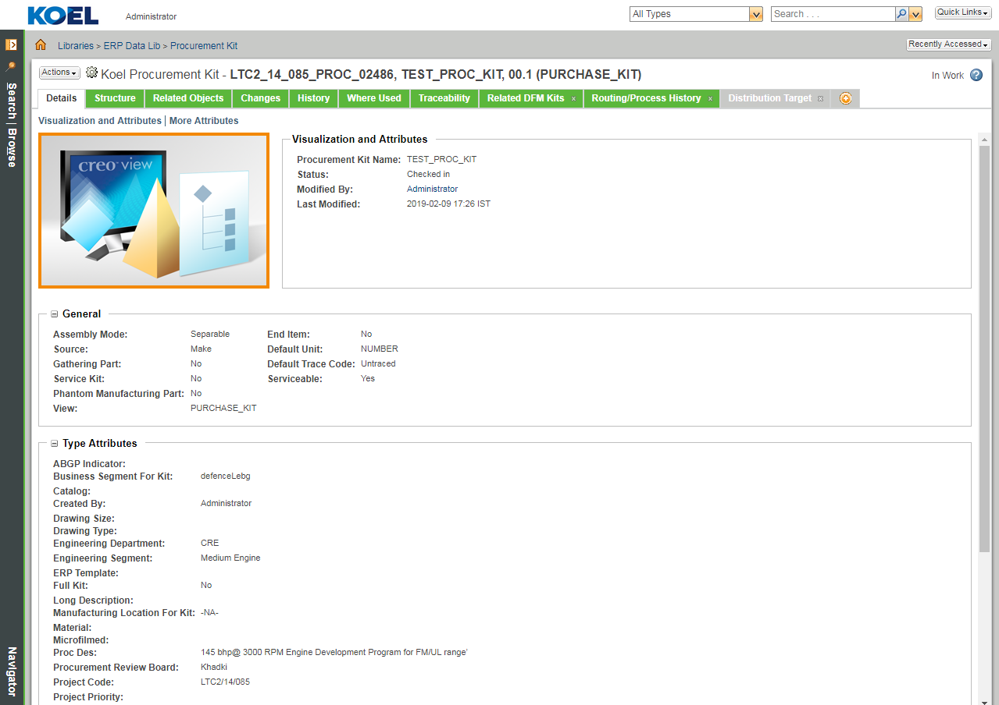
The above image shows the Details page for Koel Procurement Kit as (PURCHASE_KIT) view

- Once the Procurement Kit is created. Click on Actions Import to ProcKit as seen in below fig.
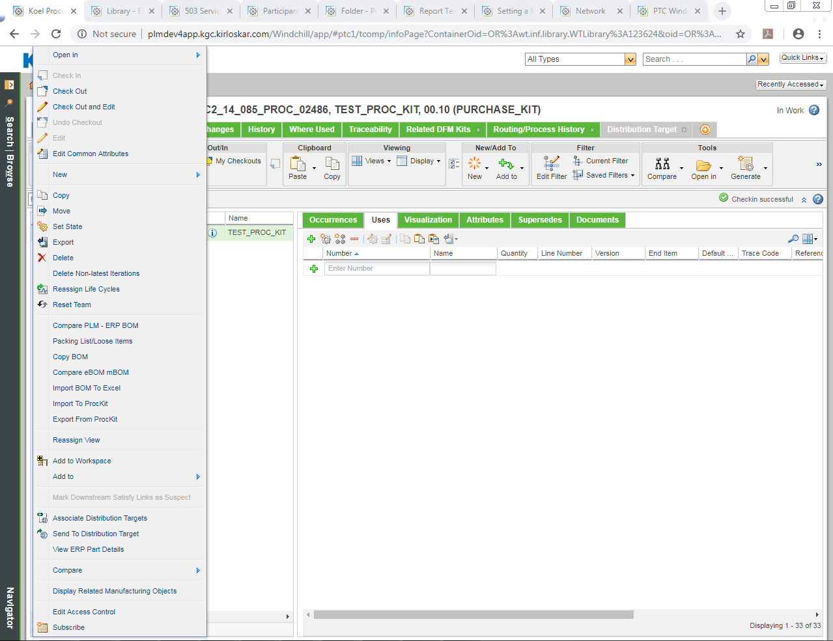
- It will launch new wizard .Choose File to upload from the system & Click on Upload File to Server.
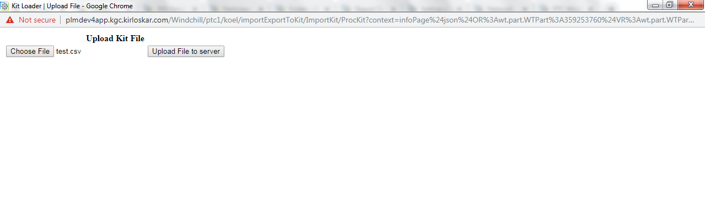
- All parts from excel sheet will get imported into the kit as seen in below figure.
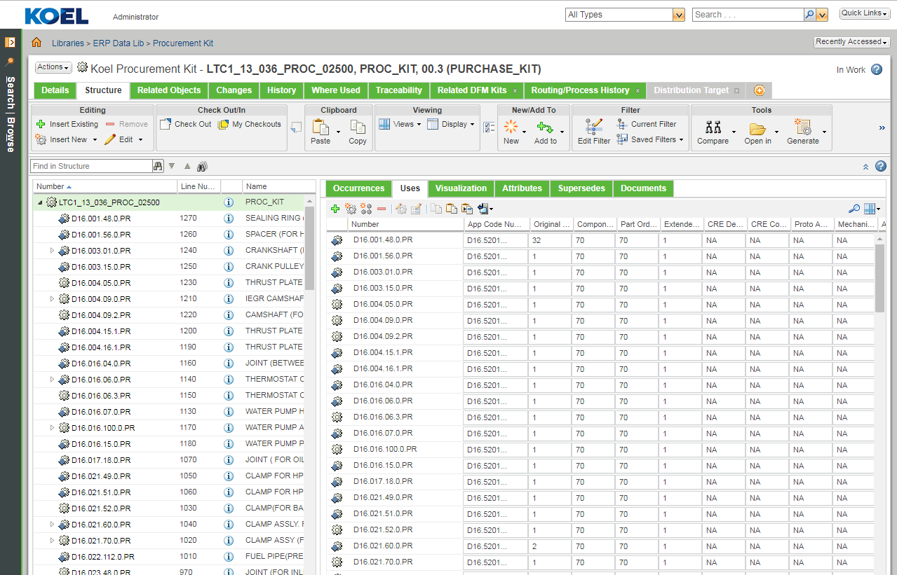
- The below task will be assigned to creator (PMO).To send kit for availing quantities.
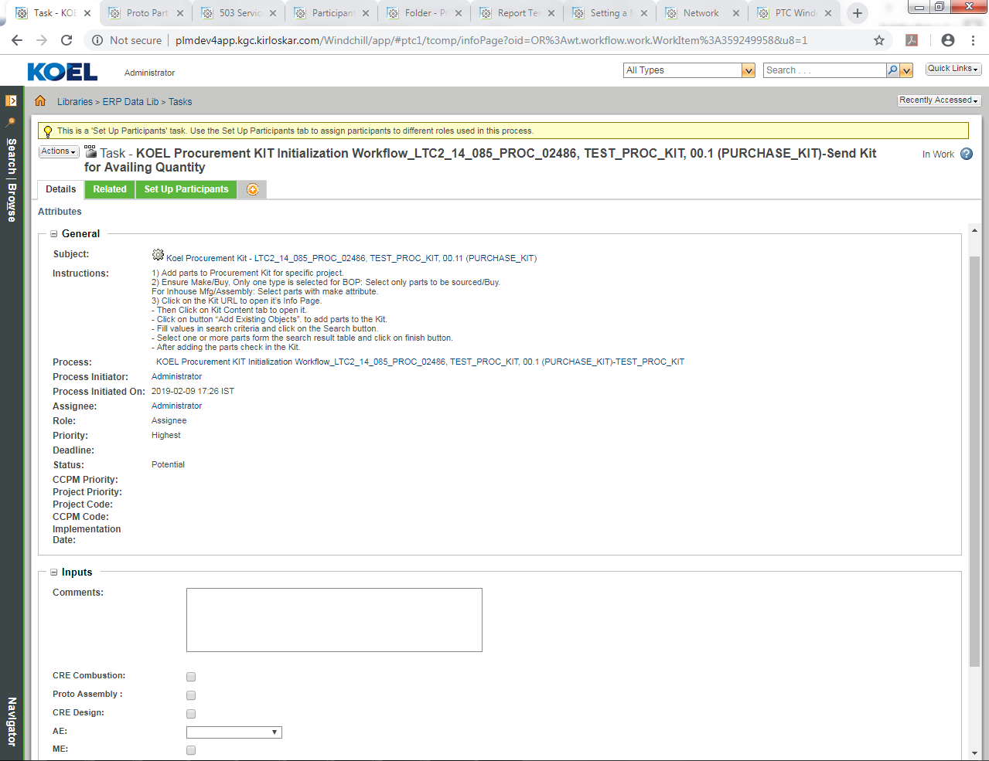

- Creator will select the departments from which the quantities are required.
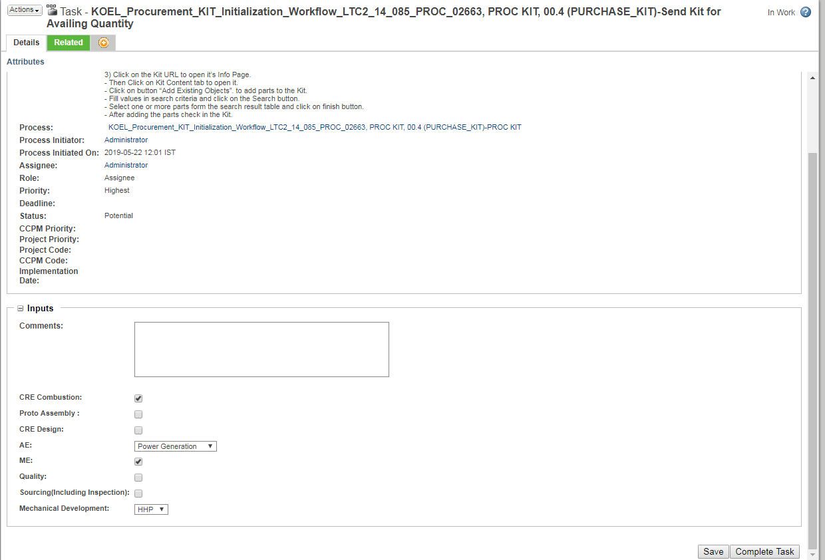
- On completion of Review kit task, If Procurement Kit part is present in DFM kit and if Minimum Order Quantity & Estimated Development lead time (In days) value is present against that part in DFM kit, then Sourcing attribute & Estimated Development lead time (In days) in procurement kit structure for respective part is updated automatically.
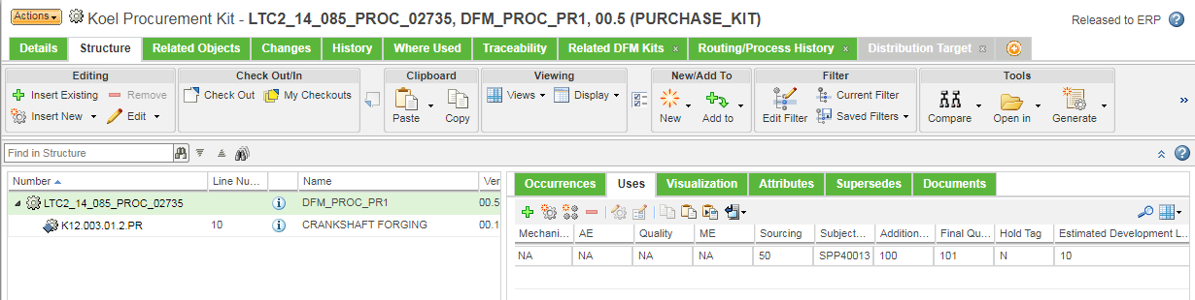
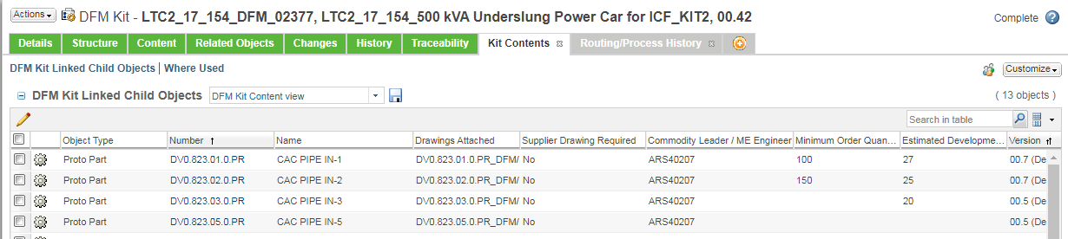

- Next task Review Kit is assigned to PMO Head in which user reviews the kit and suggests Approval / Rework of Kit.
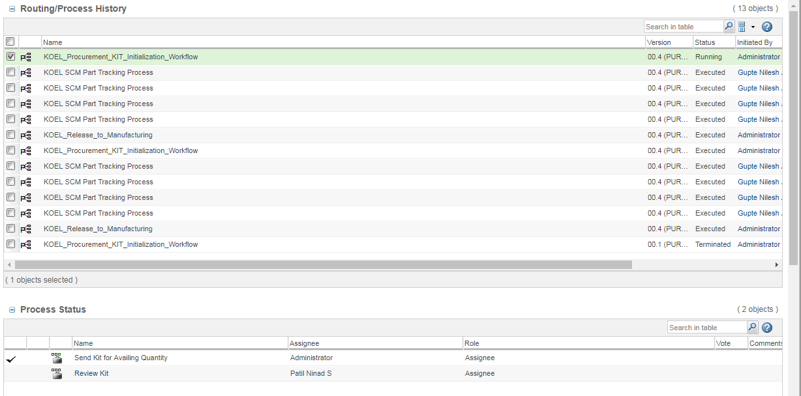

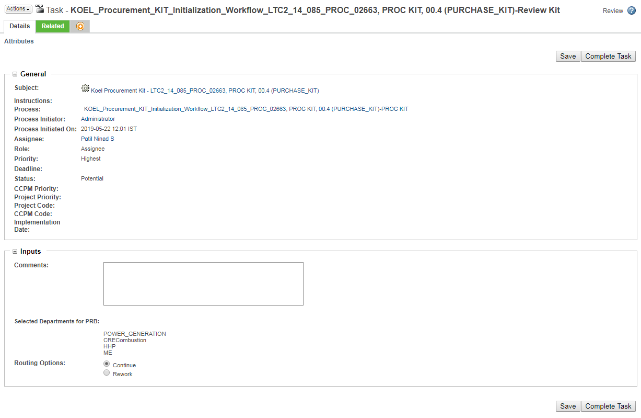

- Kit state changes to PRB & task of PRB Department Review will be assigned to the users in selected departments parallel for PRB, According to the Engineering Department, Location, Engineering Segment and Business Segment selected while kit creation.
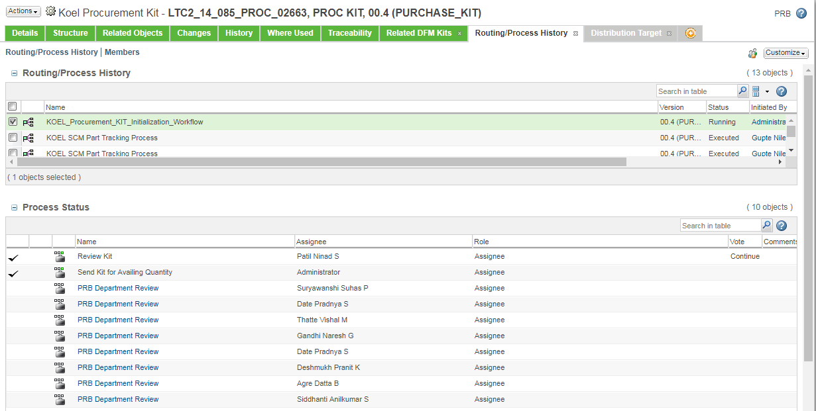

- User selects the task, the task window appears as follows. The user has to select the subject (Proc kit) to enter their required quantities against parts.
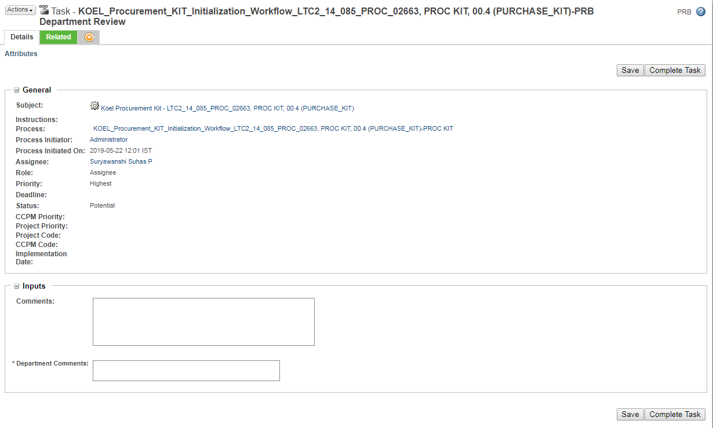

- User will open the kits Structure tab & enter their required quantity against parts by checking out the kit.
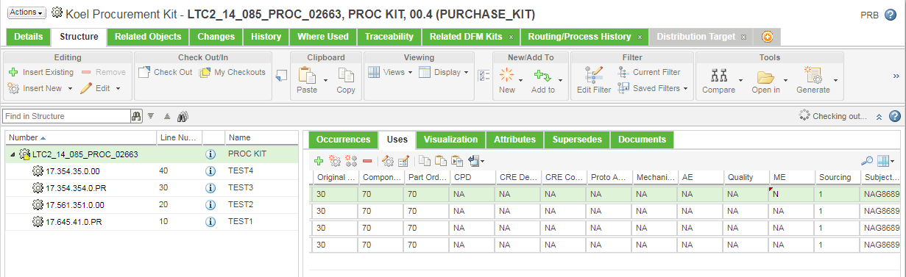
- Once all changes of quantity updating are done user have to save their changes by checking the kit as follows:
Actions Check in
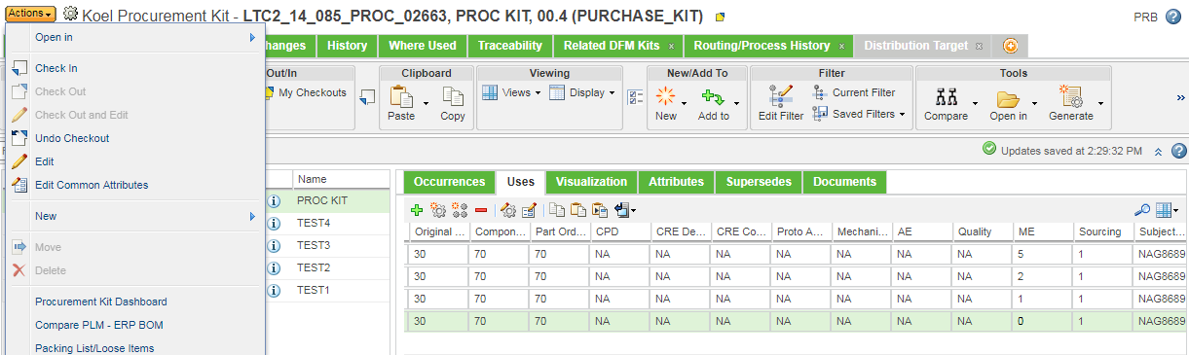
User has to complete the task after checking in successfully & by entering valid Department comments.
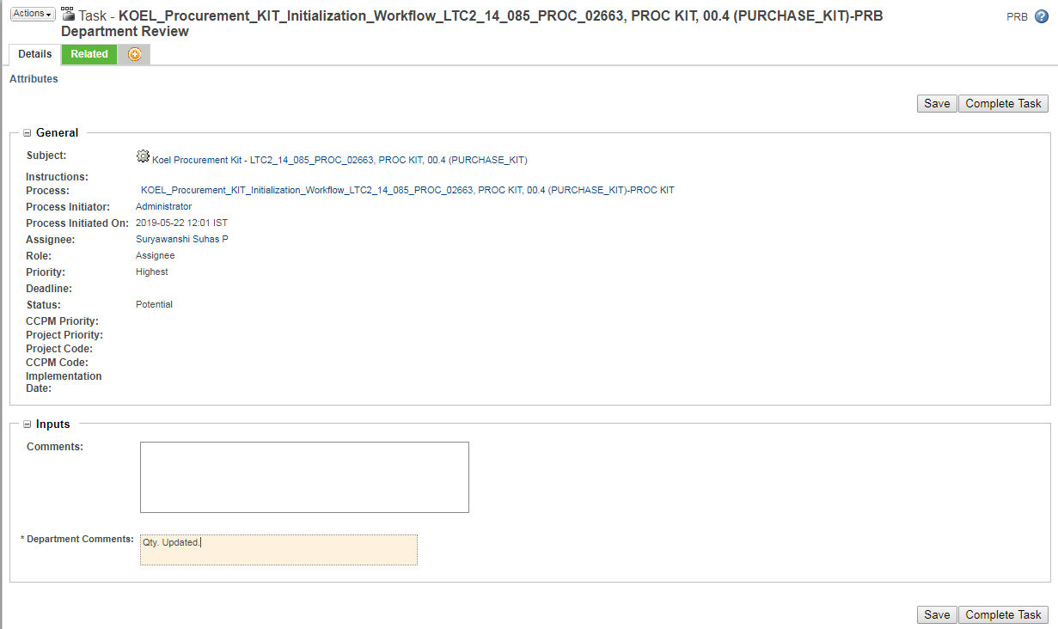

Note : Users in this task should enter the quantity under their Dept. tab only & then complete their task.
- Other departments will update their quantities as above. Once all departments have updated their quantities kit appears as follows.
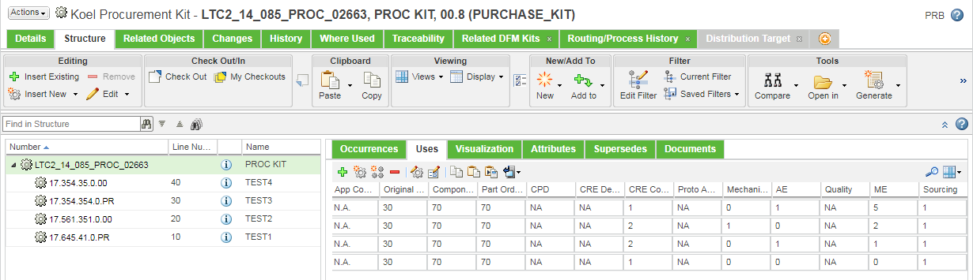
- On completion of PRB tasks, if addition of other departmental quantities is greater than sourcing quantity then addition of other departmental quantities is updated in Final Quantity attribute & if addition of other departmental quantities is less than sourcing quantity then sourcing quantity is updated in Final Quantity attribute.
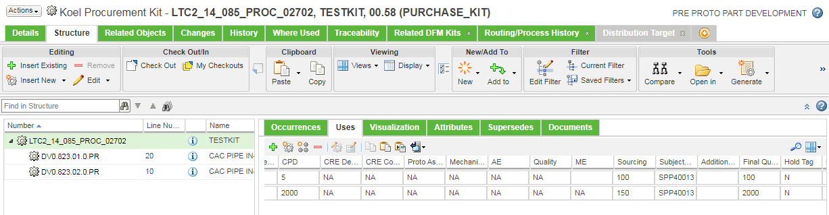

- Once all the quantities are provided “Provide Final Quantity task” will be assigned to PMO department. PMO department will provide the final authorize quantity and complete the task. All the quantities provided by the PRB Department members are visible to PMO Department.
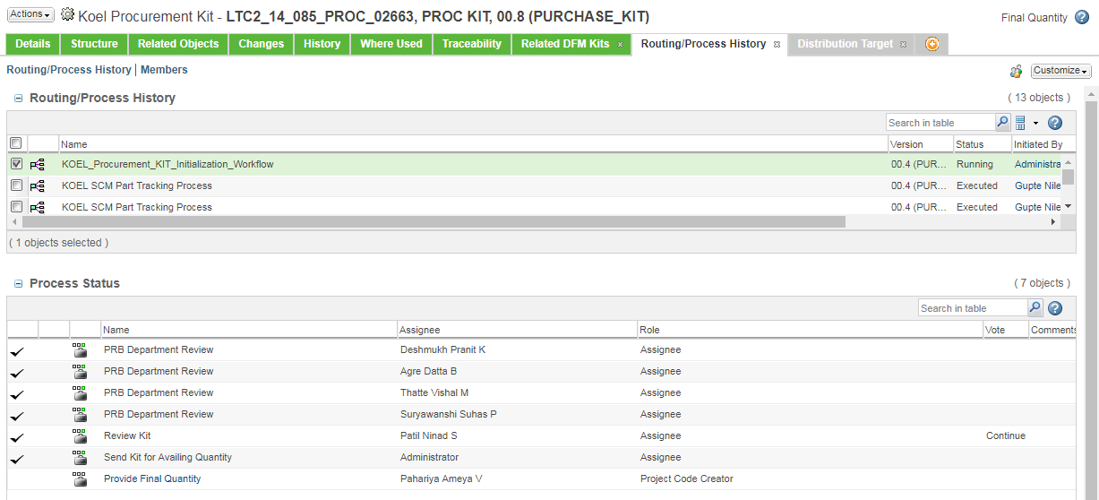

User selects the task & gets the task window with comments given by PRB Departments as follows
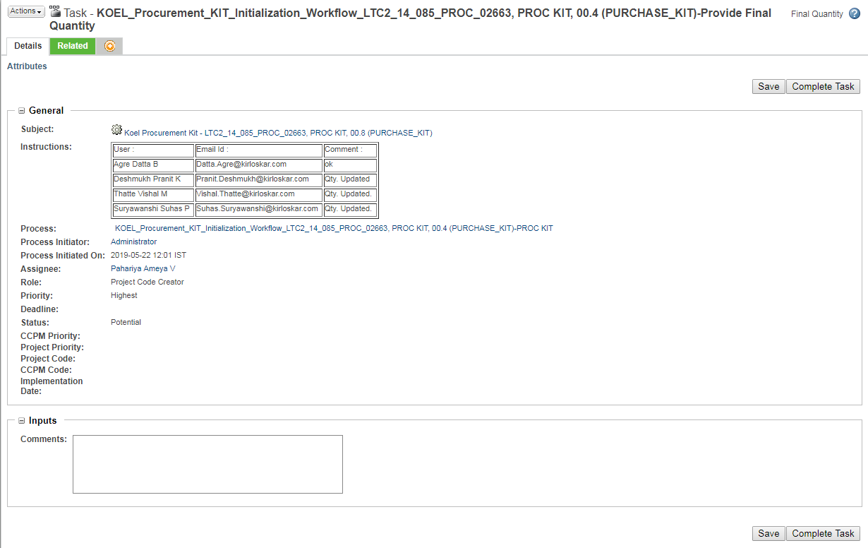

- PMO User selects the subject in task & makes changes in structure tab similar to the process of PRB Departments for providing quantity. After providing final quantity user check in the kit to save the changes.
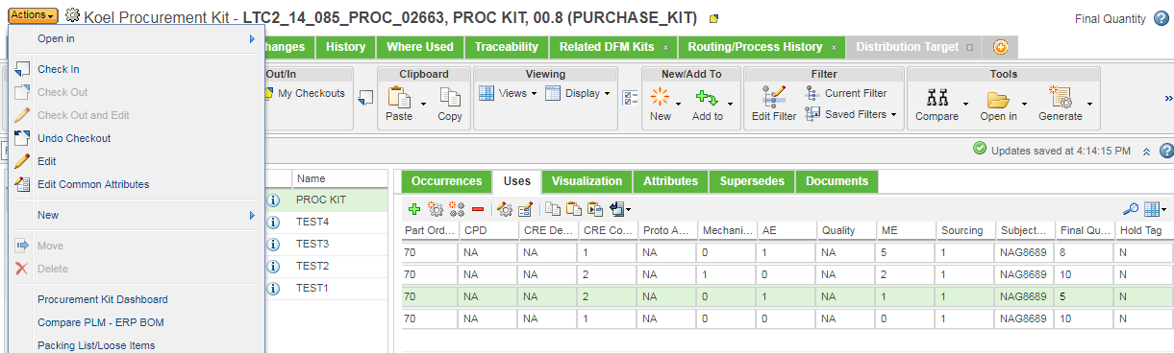

- After successful check in the user completes the task & kits state is set to Publish Part to ERP.
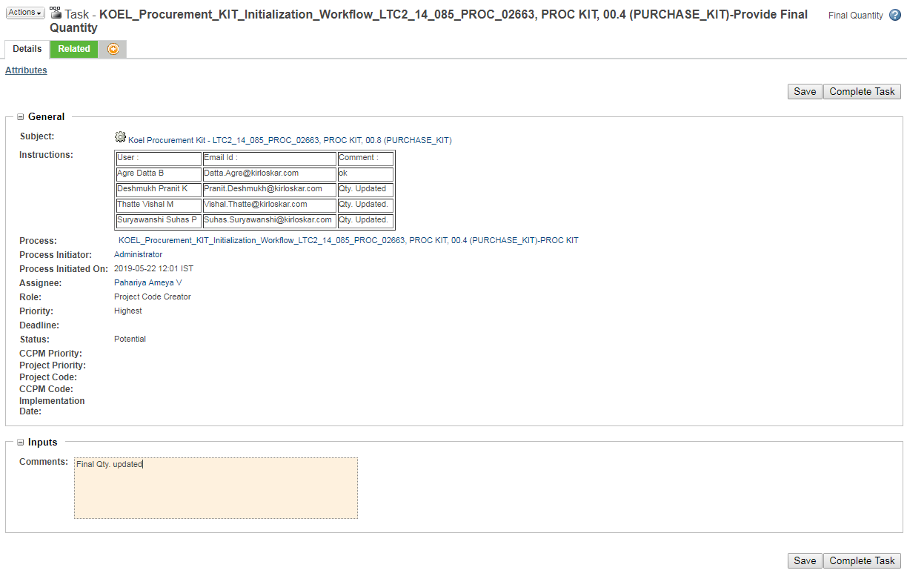

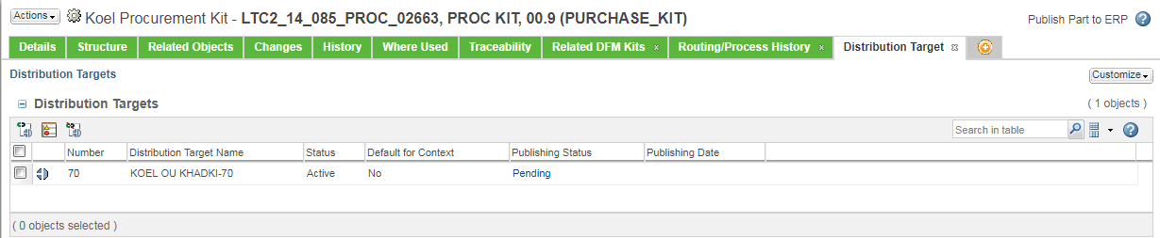

- After successful publishing kits state changes to Released to ERP.
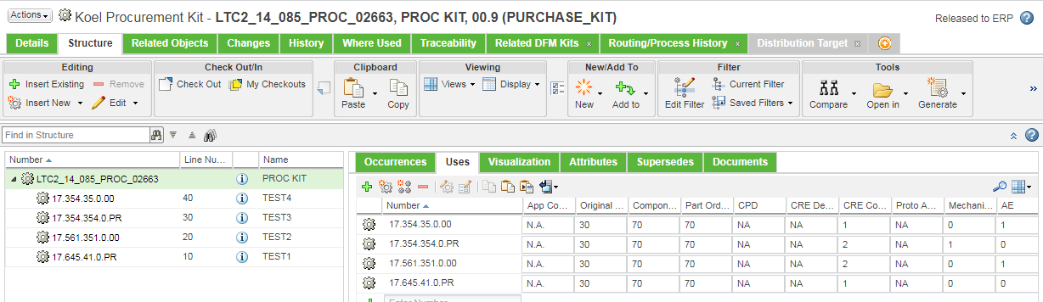

New Part Development Process:

- Part Development is triggered after kit’s state changes to Released to ERP. The kit’s state changes to Pre Proto Part Development & notification is triggered to commodity leaders of part present in kit to start part development process.
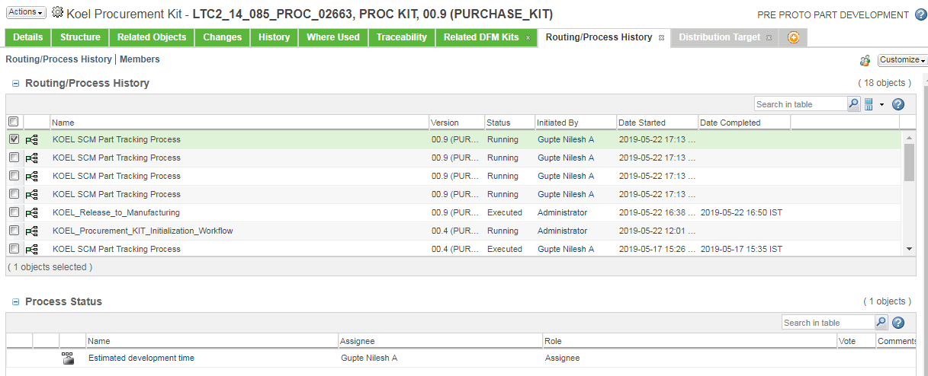

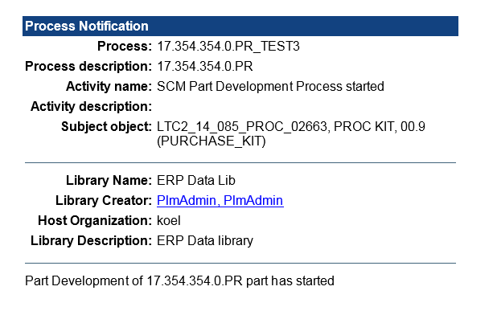

- The New Part Development Process is explained in following document.

- When all parts have their Part status as Proto part decision (User has completed the Proto part decision task for all parts in kit) kits state changes to Part Development Closure & Part Development Closure_Sourcing task is triggered to Sourcing Coordinators.
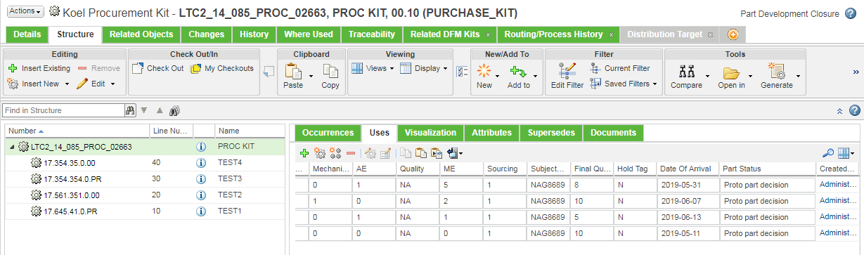

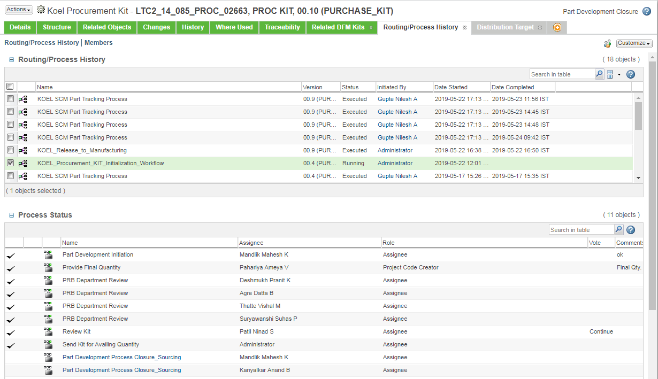

Additional Quantity Tracking Process:
- Additional Quantity Tracking Process is triggered against part used in Prockit after kit is successfully Released to ERP & Additional quantity requirement field against that part in Prockit is filled properly.
- Part Status of parts under New Part Development Process will be ‘NPD’.
- Part Status of parts under Additional Quantity Procurement Process will be ‘AQR’.
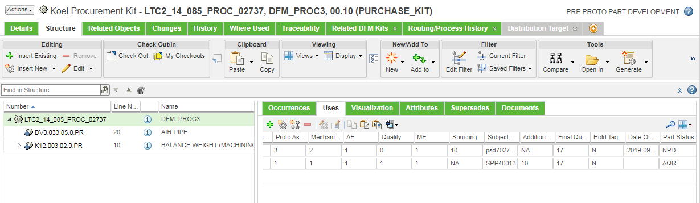
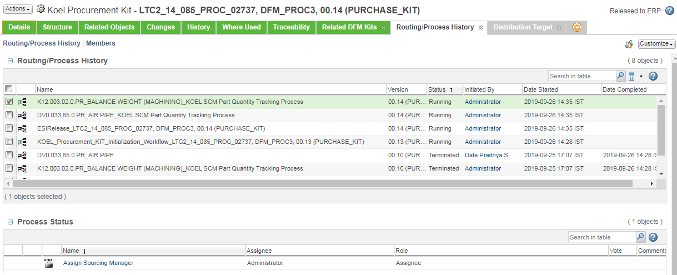

- Additional Quantity Tracking Process is explained in following document.

Procurement Kit Closure:

- Procurement Kit closure is done by Sourcing Coordinators by checking the PO & Inventory Report.
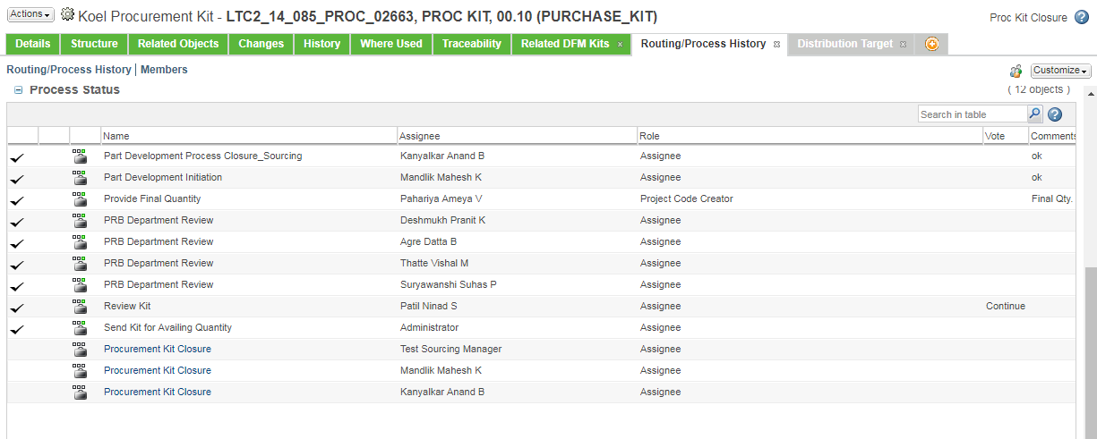

- To view the Reports user has to select Actions Procurement Kit Dashboard the following window appears.
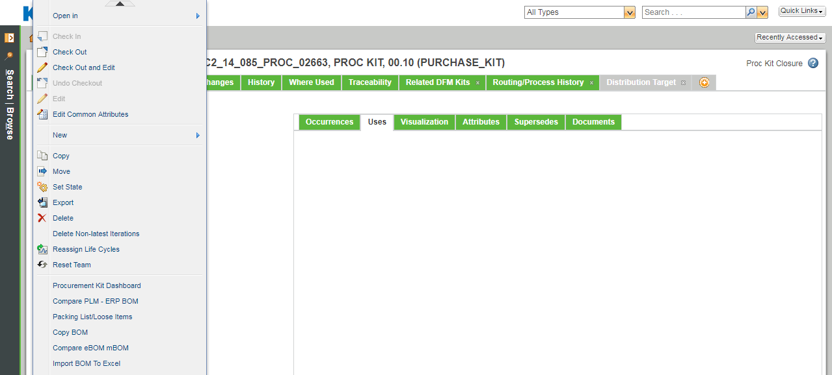

- User has to select the type of report as per requirement & select Generate.
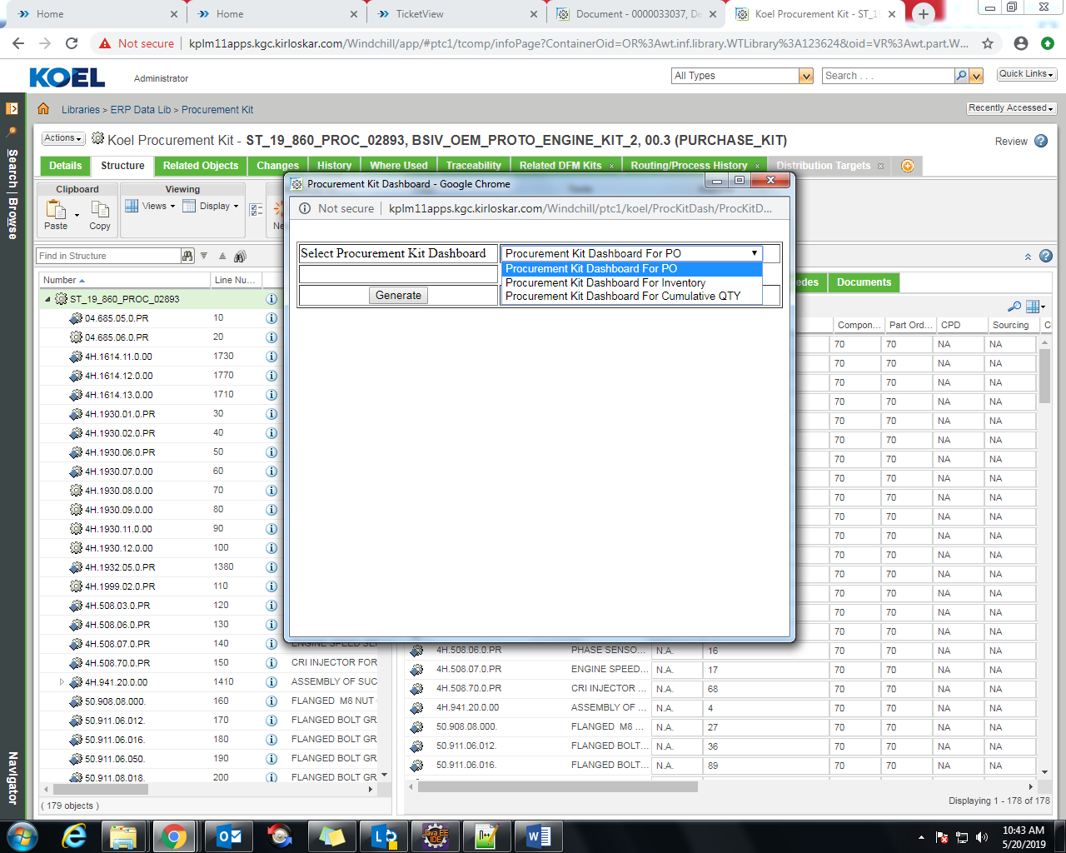
- Following is the Dashboard for PO.

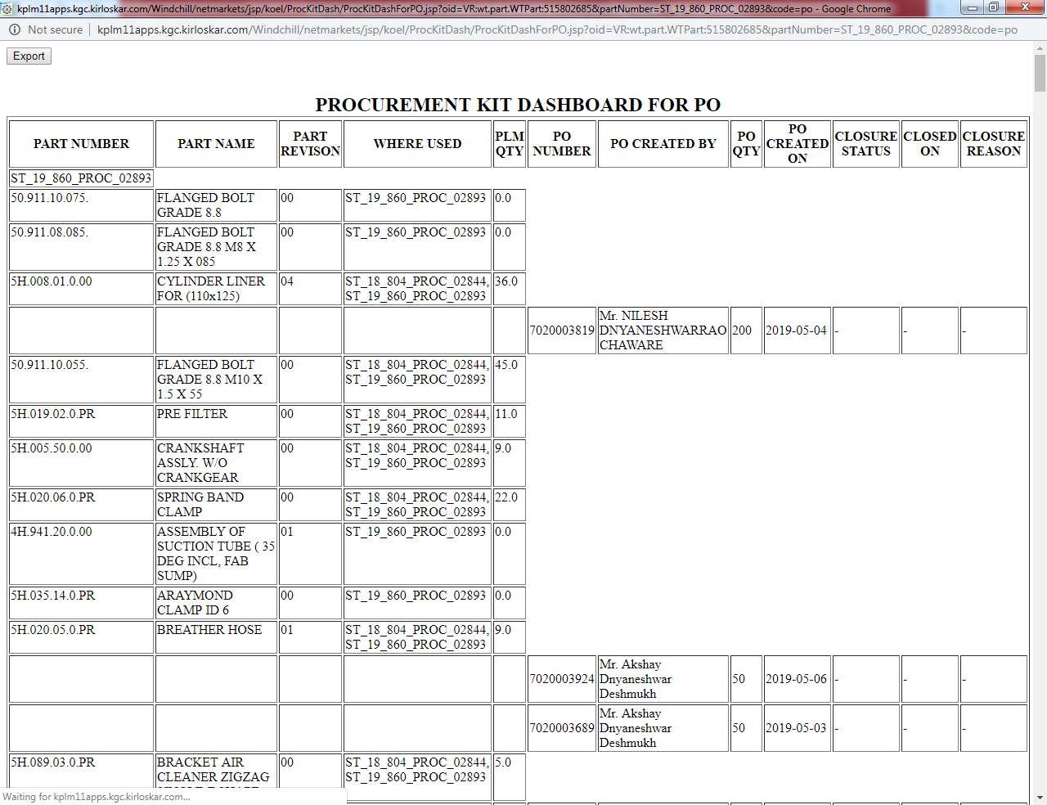

- Following is the Dashboard for Inventory.
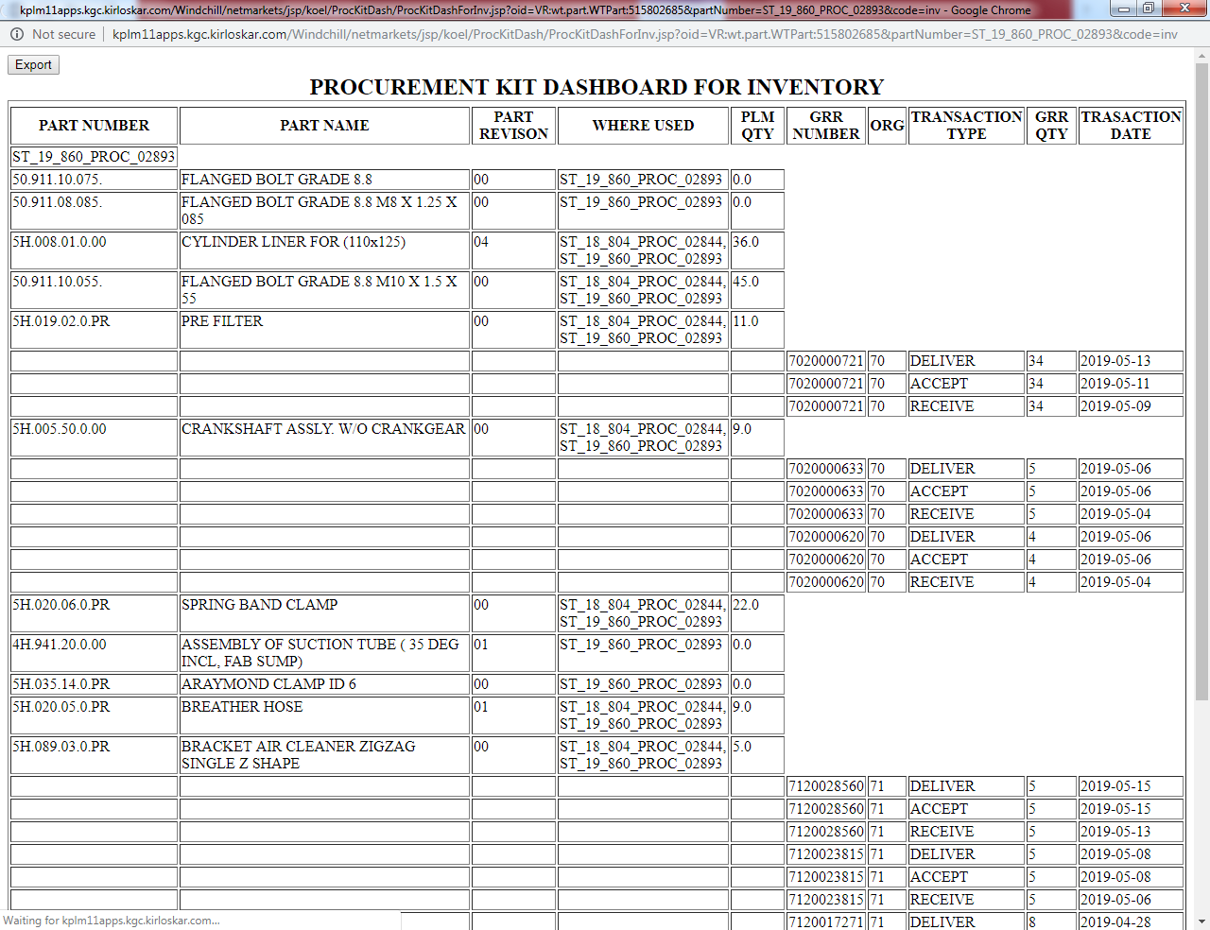
- Following is the Dashboard for Cumulative Quantity.
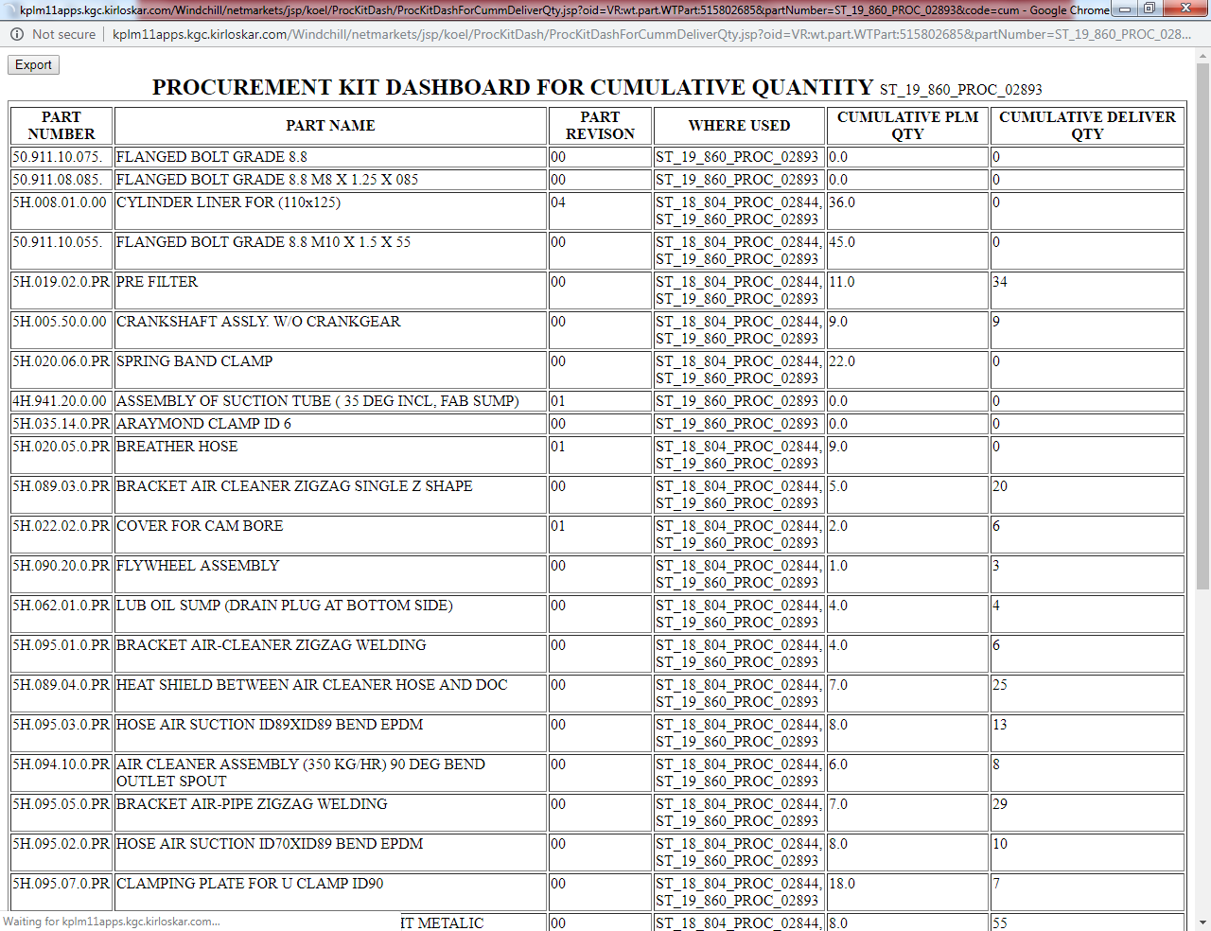

.

Revision of Kit for Updating hold tag:
- Click Action New New Promotion Request
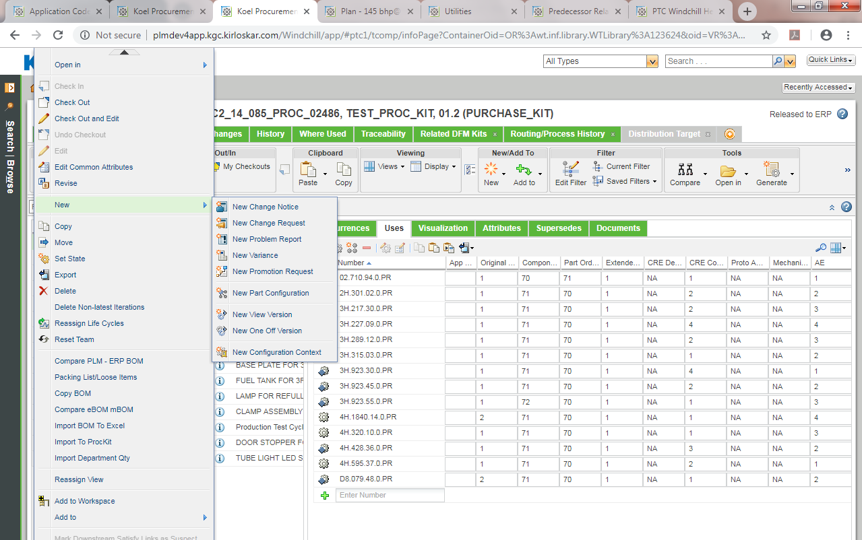

- Click Action Revise

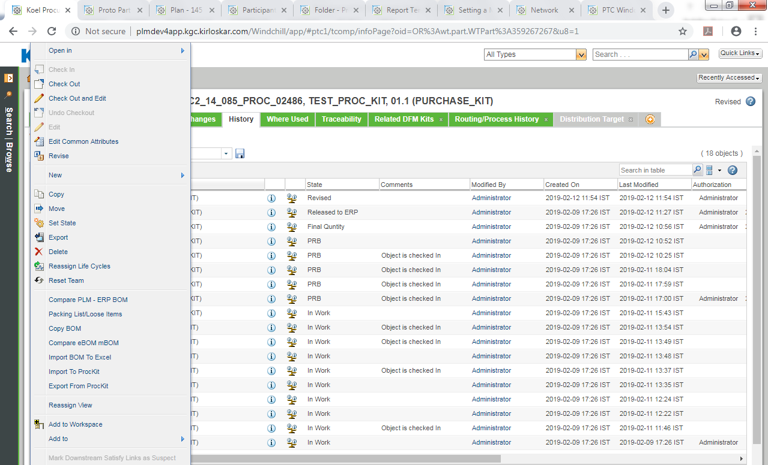

- Click on Ok the state changes to Revised & task to Update Hold Tag is displayed.
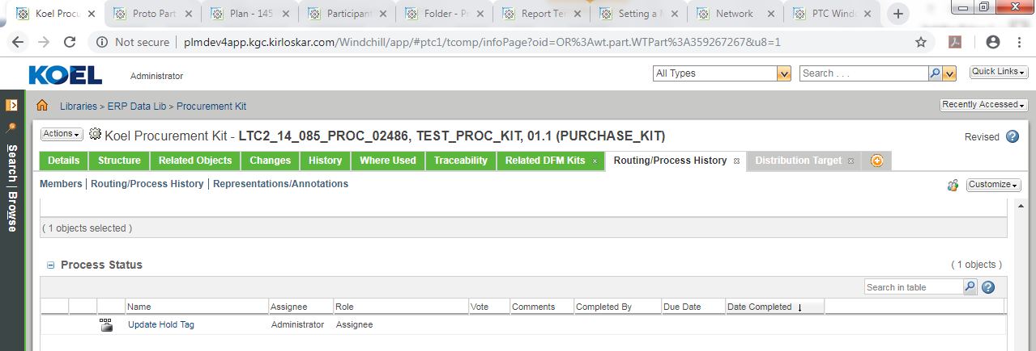

- The assignee updates the hold tag status of affected parts / Parts on which change will occur to “Y”. Initially all parts have hold tag as “N”.
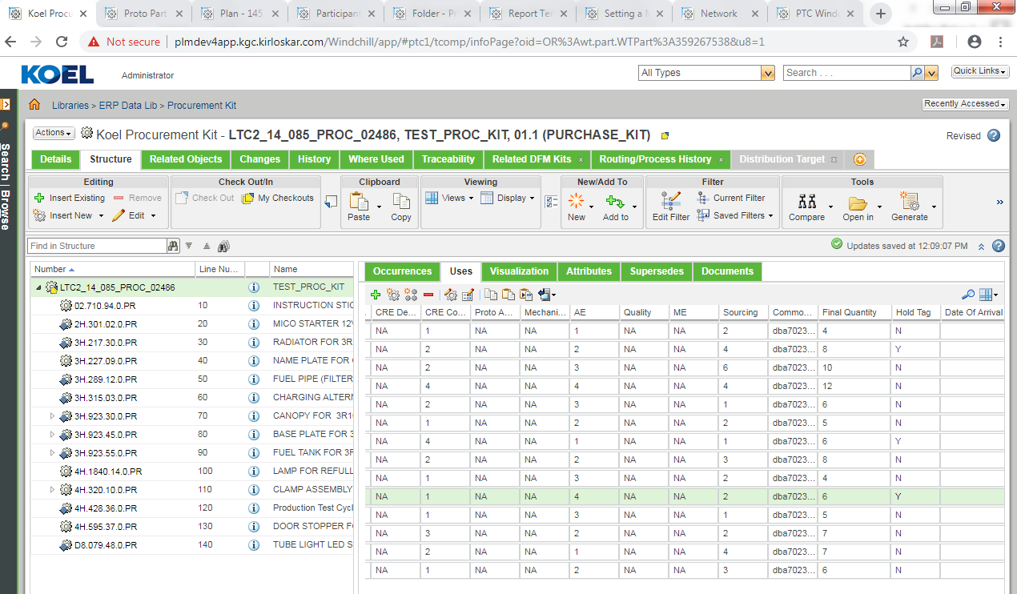

- Again kit’s state is set to Publish to ERP & the kit is Released to ERP.
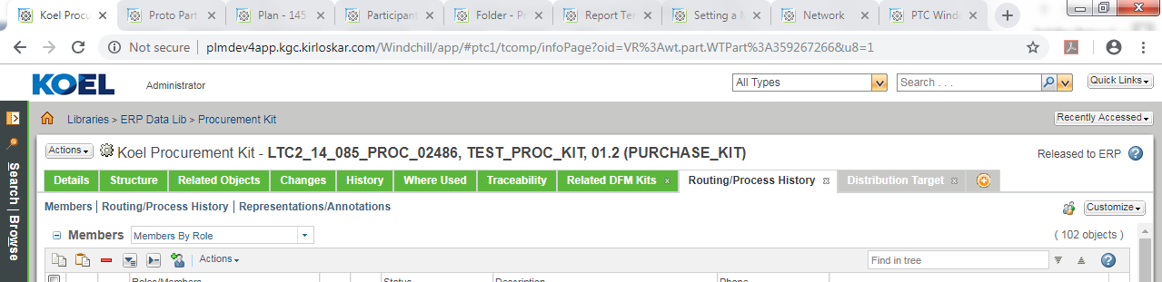

6. Procurement Kit Task Report:

- For Kit task tracking open the ERP Data Library context & select Reports tab.
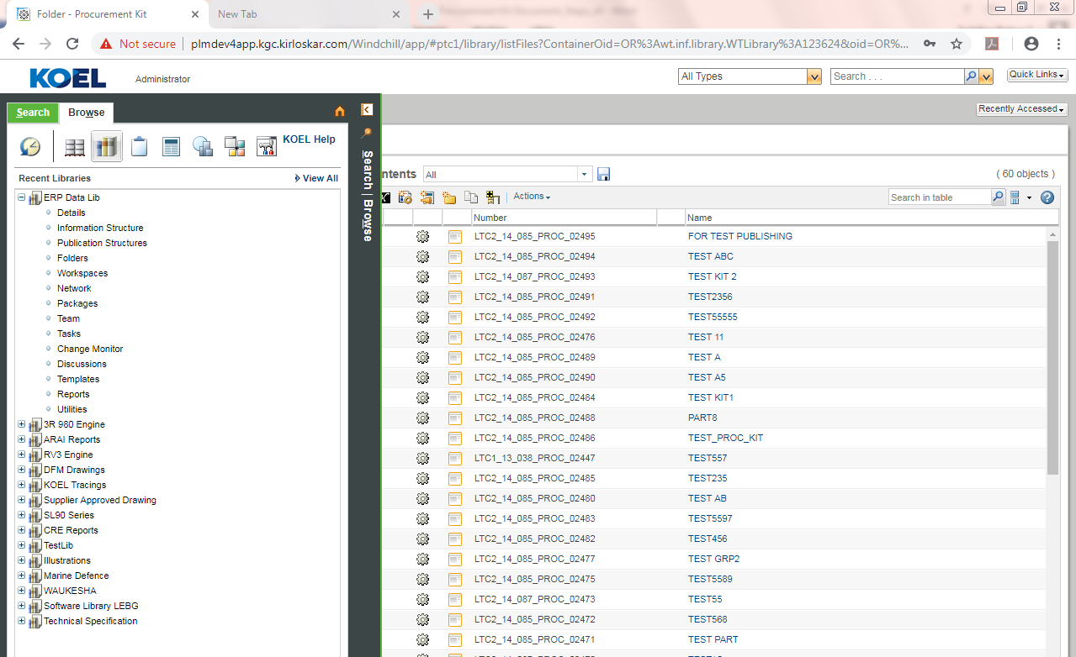
- In the ERP Data Lib section select the Procurement Kit Parts Tracking Report a new window of report builder will appear a new window with data of all kits will appear.
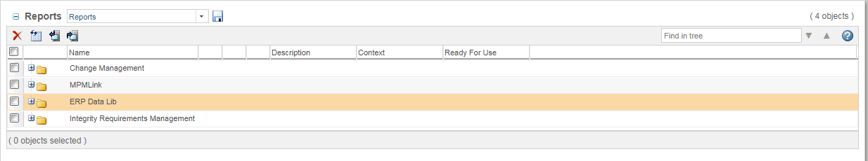

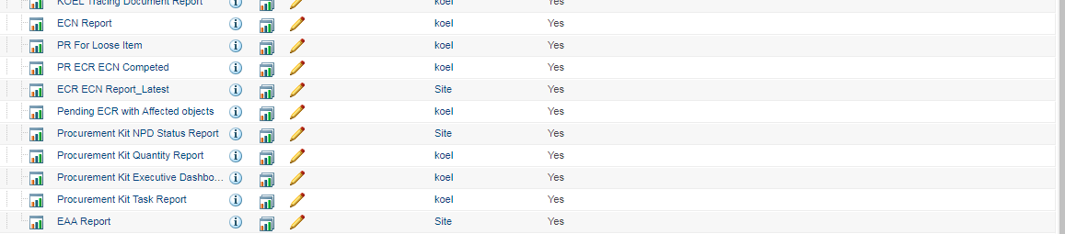

- Fill the Name / Number of required kit & select Generate.

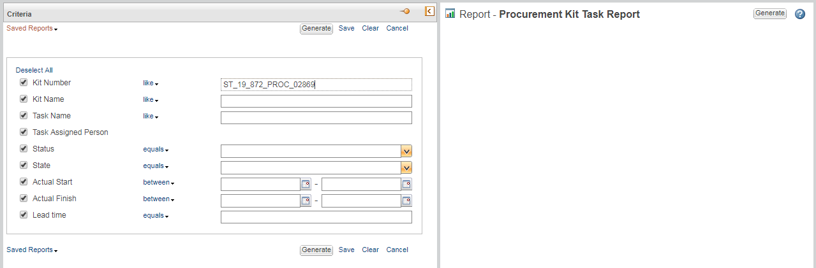

- Required report data will appear as follows.
